4. Develop a Java program to create an interface ParkingCharge containing the methods calculateCharge() and displayParkingDetails(). Create a class VehicleParking with members Vehicle Number, Vehicle Type, and Parking Hours. Derive the classes TwoWheeler and FourWheeler from VehicleParking and implement the interface. Calculate the parking charge as follows: For TwoWheeler, charge Rs. 20 per hour for the first two hours and Rs. 10 per hour for each additional hour. For FourWheeler, charge Rs. 50 per hour for the first two hours and Rs. 30 per hour for each additional hour. Display vehicle details and total parking charge. Demonstrate runtime polymorphism using a ParkingCharge reference.
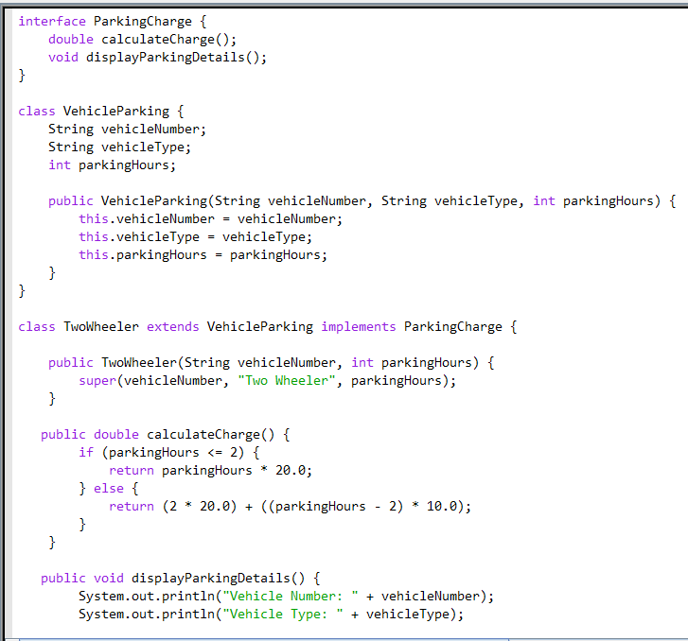
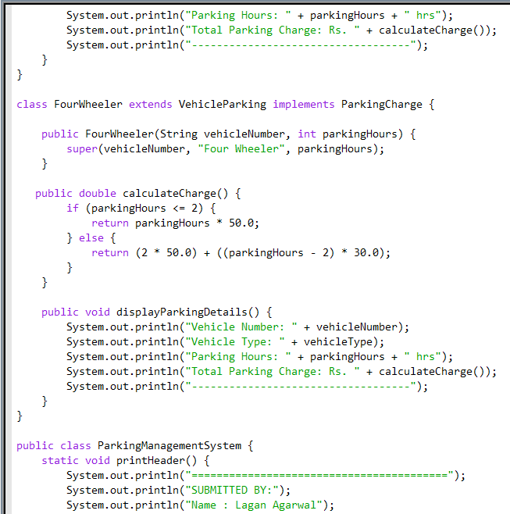
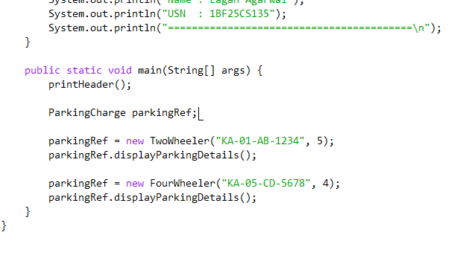

OUTPUT:


